**STUDENT NAME: P. HASINI**

**REG NUMBER : 192111535**

**SUBJECT NAME : OPERATING SYSTEM WITH DESIGN PRINCIPLES**

**SUBJECT CODE : CSA0470**

DAY 1 PROGRAMS(SEP 26,2022)

**1.PROGRAM**

#include<stdio.h>

#include<unistd.h>

#include<sys/types.h>

int main()

{

pid_t p;

printf("before fork\n");

p=fork();

if(p==0)

{

printf("I am child having id %d\n",getpid());

printf("My parent's id is %d\n",getppid());

}

else{

printf("My child's id is %d\n",p);

printf("I am parent having id %d\n",getpid());

}

printf("Common\n");

}

**OUTPUT**

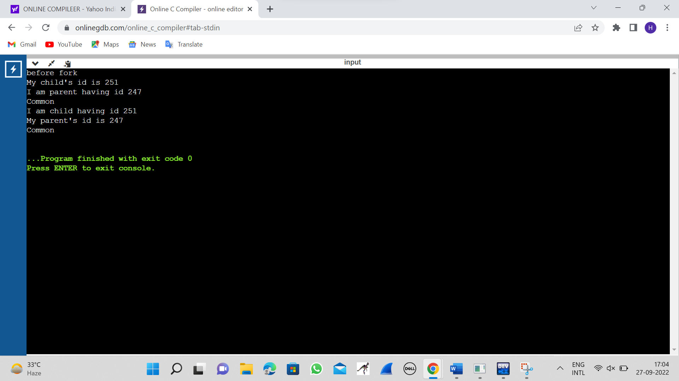

**2.PROGRAM**

#include <stdio.h>

#include <stdlib.h>

int main(){

FILE *fptr1, *fptr2;

char filename[100], c;

printf("Enter the filename to open for reading \n");

scanf("%s",filename);

fptr1 = fopen(filename, "r");

if (fptr1 == NULL){

printf("Cannot open file %s \n", filename);

exit(0);

}

printf("Enter the filename to open for writing \n");

scanf("%s", filename);

fptr2 = fopen(filename, "w");

if (fptr2 == NULL){

printf("Cannot open file %s \n", filename);

exit(0);

}

c = fgetc(fptr1);

while (c != EOF){

fputc(c, fptr2);

c = fgetc(fptr1);

}

printf("\nContents copied to %s", filename);

fclose(fptr1);

fclose(fptr2);

return 0;

}

**OUTPUT**

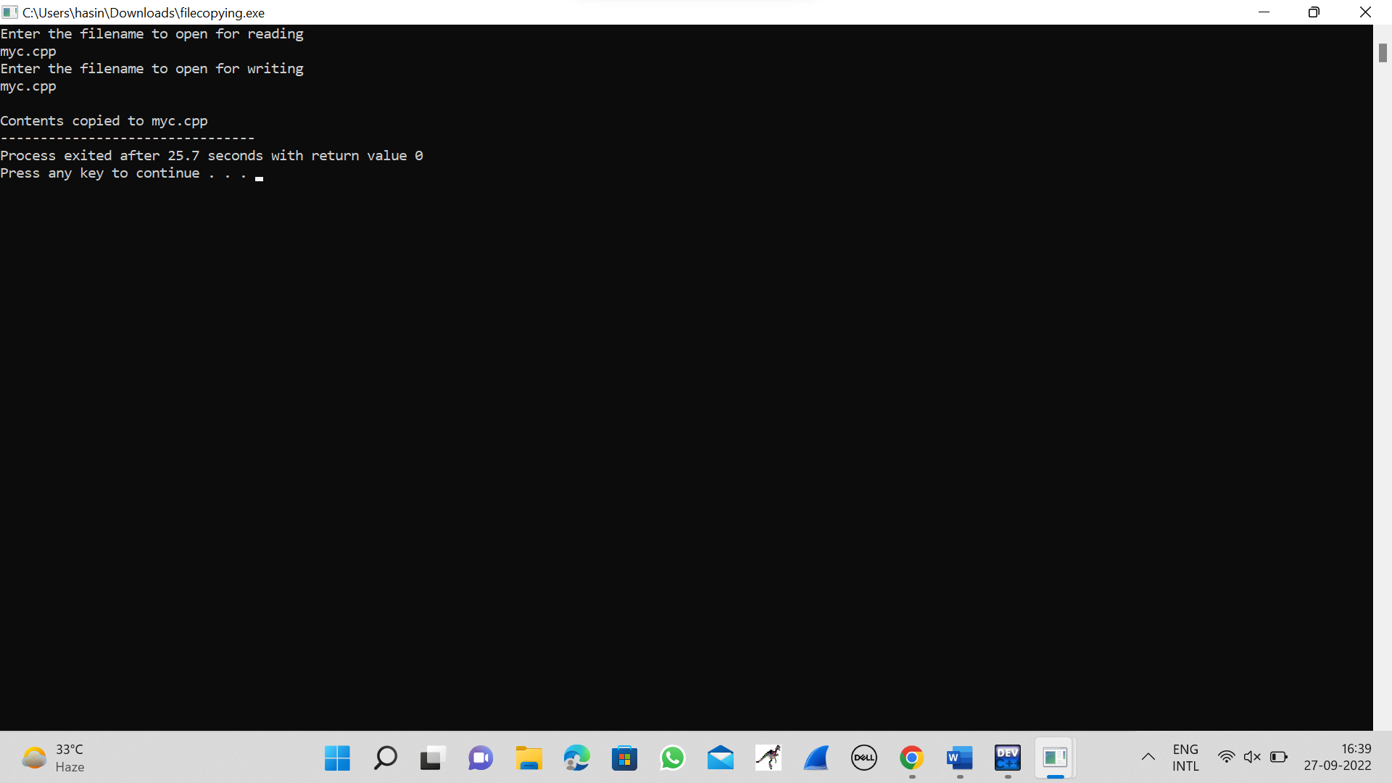

**3.PROGRAM**

#include<stdio.h>

int main()

{

int bt[10]={0},at[10]={0},tat[10]={0},wt[10]={0},ct[10]={0};

int n,sum=0;

float totalTAT=0,totalWT=0;

printf("Enter number of processes ");

scanf("%d",&n);

printf("Enter arrival time and burst time for each process\n\n");

for(int i=0;i<n;i++)

{

printf("Arrival time of process[%d] ",i+1);

scanf("%d",&at[i]);

printf("Burst time of process[%d] ",i+1);

scanf("%d",&bt[i]);

printf("\n");

}

for(int j=0;j<n;j++)

{

sum+=bt[j];

ct[j]+=sum;

}

for(int k=0;k<n;k++)

{

tat[k]=ct[k]-at[k];

totalTAT+=tat[k];

}

for(int k=0;k<n;k++)

{

wt[k]=tat[k]-bt[k];

totalWT+=wt[k];

}

printf("Solution: \n\n");

printf("P#\t AT\t BT\t CT\t TAT\t WT\t\n\n");

for(int i=0;i<n;i++)

{

printf("P%d\t %d\t %d\t %d\t %d\t %d\n",i+1,at[i],bt[i],ct[i],tat[i],wt[i]);

}

printf("\n\nAverage Turnaround Time = %f\n",totalTAT/n);

printf("Average WT = %f\n\n",totalWT/n);

return 0;

}

**OUTPUT**

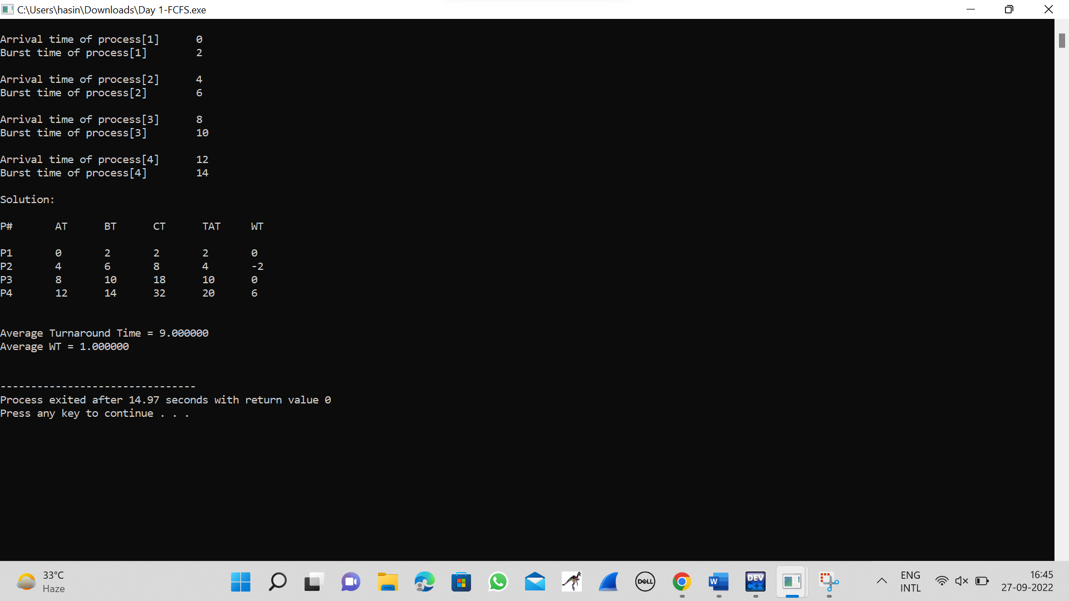

**4.PROGRAM**

#include <stdio.h>

int main()

{

int A[100][4];

int i, j, n, total = 0, index, temp; float avg_wt, avg_tat;

printf("Enter number of process: "); scanf("%d", &n);

printf("Enter Burst Time:\n");

for (i = 0; i < n; i++) {

printf("P%d: ", i + 1); scanf("%d", &A[i][1]); A[i][0] = i + 1;

}

for (i = 0; i < n; i++) {

index = i;

for (j = i + 1; j < n; j++)

if (A[j][1] < A[index][1]) index = j;

temp = A[i][1]; A[i][1] = A[index][1]; A[index][1] = temp;

temp = A[i][0];

A[i][0] = A[index][0]; A[index][0] = temp;

}

A[0][2] = 0;

for (i = 1; i < n; i++) {

A[i][2] = 0;

for (j = 0; j < i; j++)

A[i][2] += A[j][1];

total += A[i][2];

}

avg_wt = (float)total / n; total = 0;

printf("P BT WT TAT\n"); for (i = 0; i < n; i++) {

A[i][3] = A[i][1] + A[i][2];

total += A[i][3];

printf("P%d %d %d %d\n", A[i][0], A[i][1], A[i][2], A[i][3]);

}

avg_tat = (float)total / n;

printf("Average Waiting Time= %f", avg_wt); printf("\nAverage Turnaround Time= %f", avg_tat);

}

**OUTPUT**

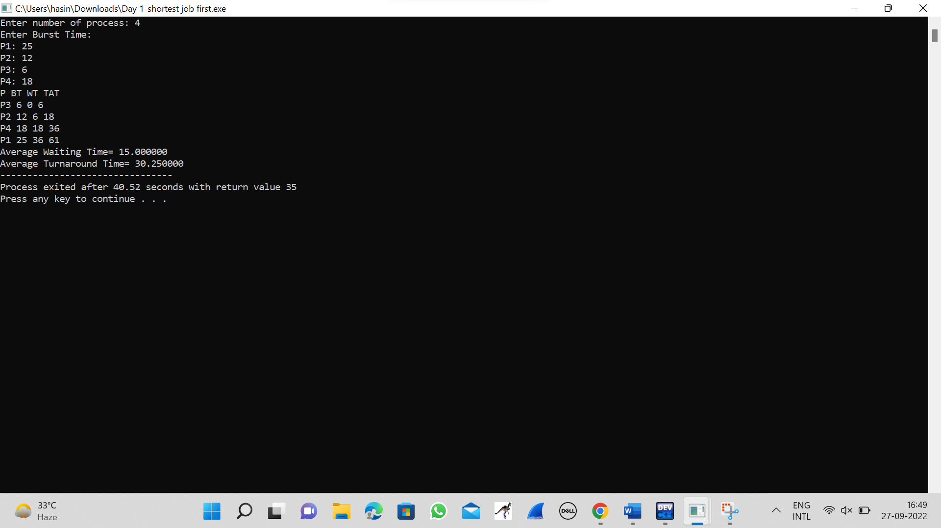

**5.PROGRAM**

#include<stdio.h>

struct priority_scheduling {

char process_name;

int burst_time;

int waiting_time;

int turn_around_time;

int priority;

};

int main() {

int number_of_process;

int total = 0;

struct priority_scheduling temp_process;

int ASCII_number = 65;

int position;

float average_waiting_time;

float average_turnaround_time;

printf("Enter the total number of Processes: ");

scanf("%d", & number_of_process);

struct priority_scheduling process[number_of_process];

printf("\nPlease Enter the Burst Time and Priority of each process:\n");

for (int i = 0; i < number_of_process; i++) {

process[i].process_name = (char) ASCII_number;

printf("\nEnter the details of the process %c \n", process[i].process_name);

printf("Enter the burst time: ");

scanf("%d", & process[i].burst_time);

printf("Enter the priority: ");

scanf("%d", & process[i].priority);

ASCII_number++;

}

for (int i = 0; i < number_of_process; i++) {

position = i;

for (int j = i + 1; j < number_of_process; j++) {

if (process[j].priority > process[position].priority)

position = j;

}

temp_process = process[i];

process[i] = process[position];

process[position] = temp_process;

}

process[0].waiting_time = 0;

for (int i = 1; i < number_of_process; i++) {

process[i].waiting_time = 0;

for (int j = 0; j < i; j++) {

process[i].waiting_time += process[j].burst_time;

}

total += process[i].waiting_time;

}

average_waiting_time = (float) total / (float) number_of_process;

total = 0;

printf("\n\nProcess_name \t Burst Time \t Waiting Time \t Turnaround Time\n");

printf("------------------------------------------------------------\n");

for (int i = 0; i < number_of_process; i++) {

process[i].turn_around_time = process[i].burst_time + process[i].waiting_time;

total += process[i].turn_around_time;

printf("\t %c \t\t %d \t\t %d \t\t %d", process[i].process_name, process[i].burst_time, process[i].waiting_time, process[i].turn_around_time);

printf("\n-----------------------------------------------------------\n");

}

average_turnaround_time = (float) total / (float) number_of_process;

printf("\n\n Average Waiting Time : %f", average_waiting_time);

printf("\n Average Turnaround Time: %f\n", average_turnaround_time);

return 0;

}

**OUTPUT**

